**Name:** mostafa Esmat Abdelmoty mostafa

# **B.N:** 917

# **Date:** 25/7.

# **Topic:** operating systems.

# **Git Hup Link:**

<https://github.com/mostafa2008/html-project-repository-.>

# The point at the end of the link is included in the link itself.

**Git Hup page (published website):**

<https://mostafa2008.github.io/html-project-repository-./>

<https://mostafa2008.github.io/html-project-repository-./statistics.html>

**Source code:**

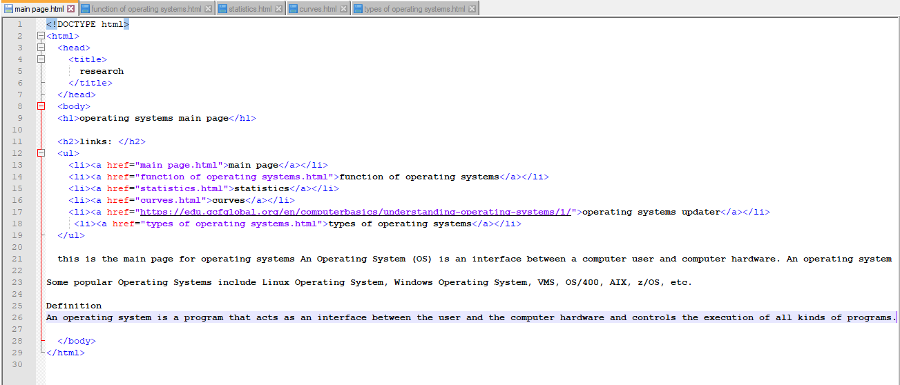

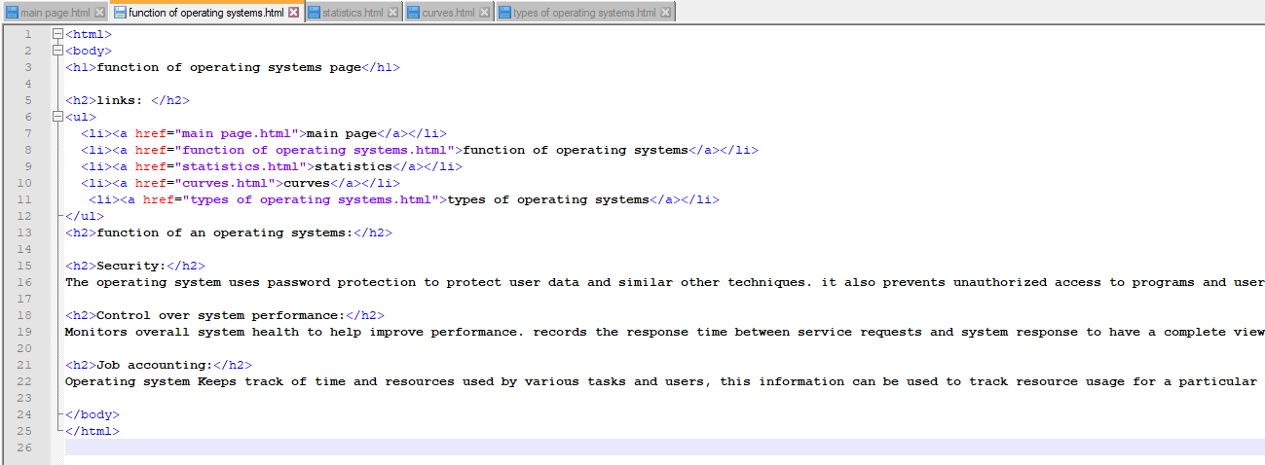

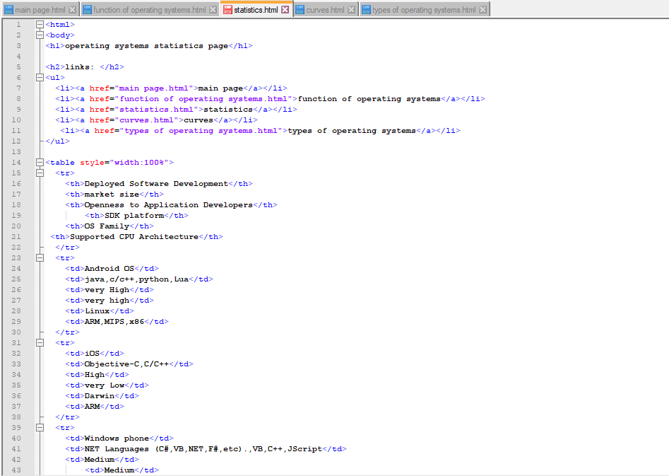

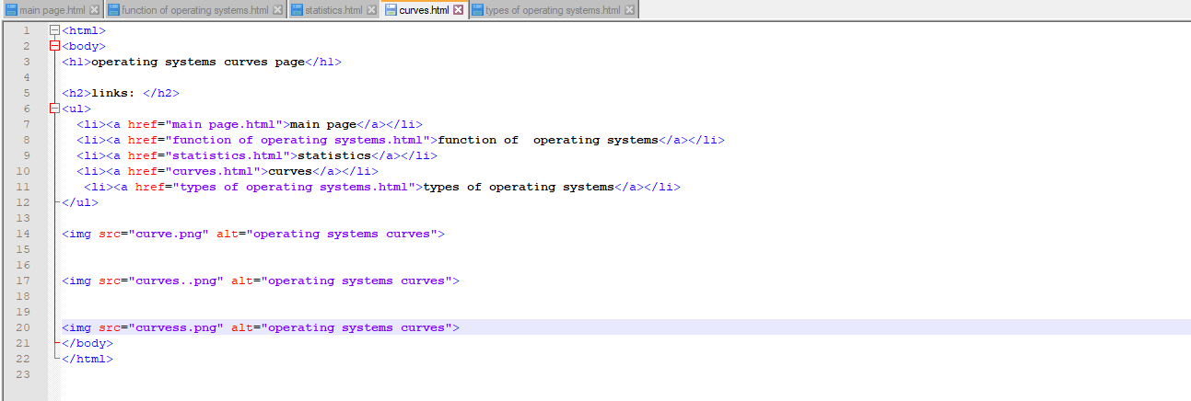

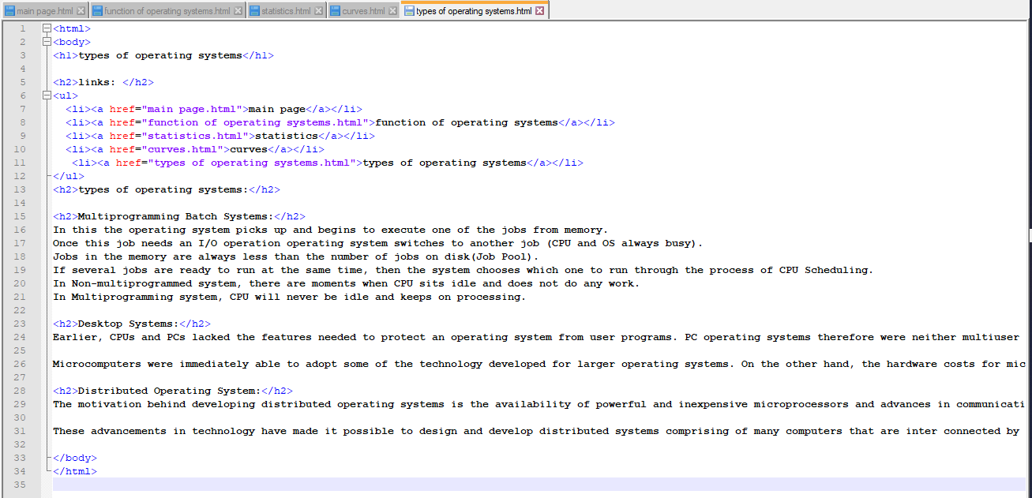

# 

**Screenshots**

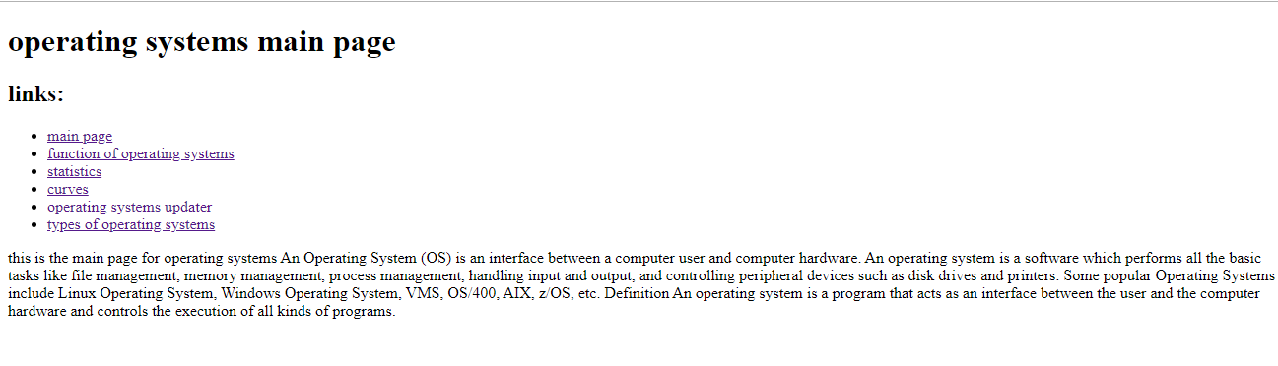

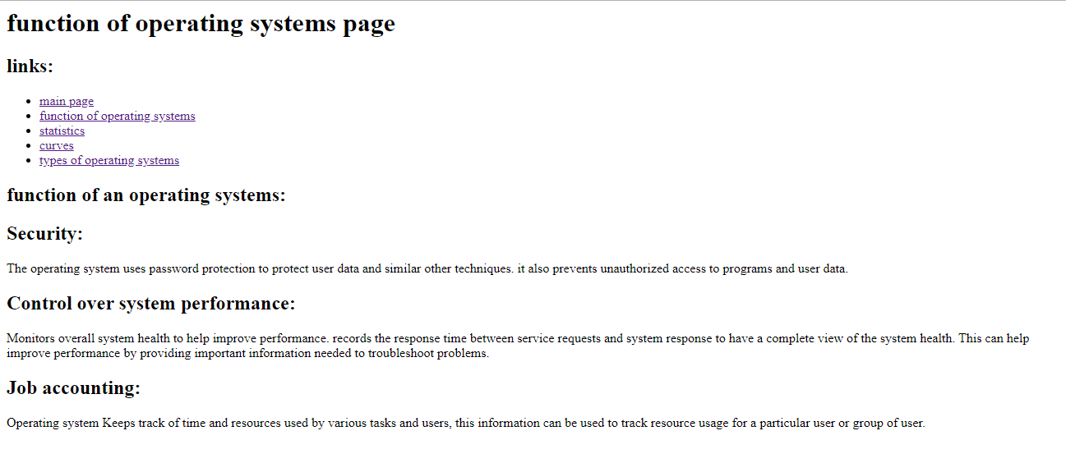

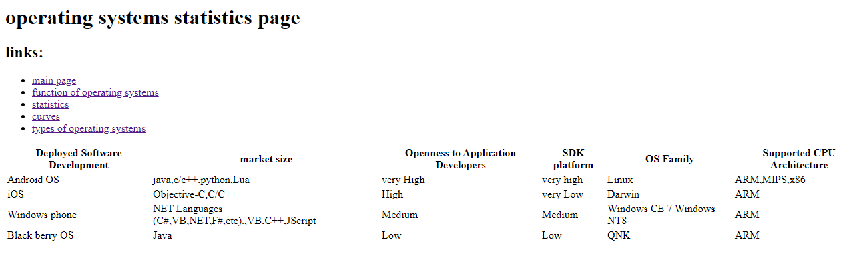

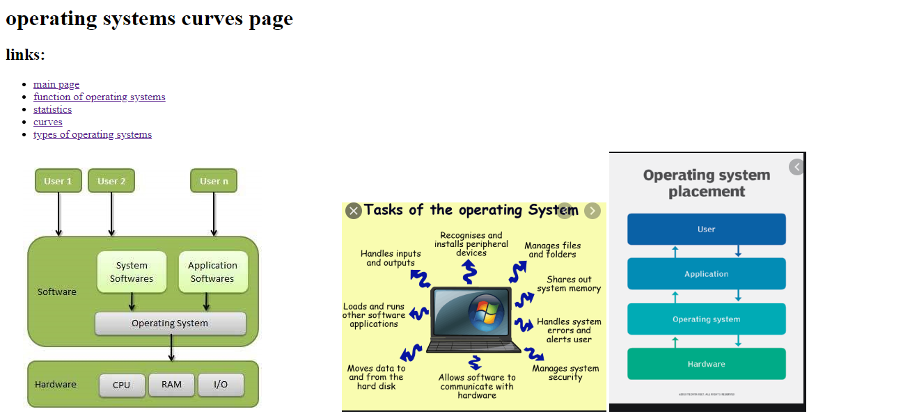

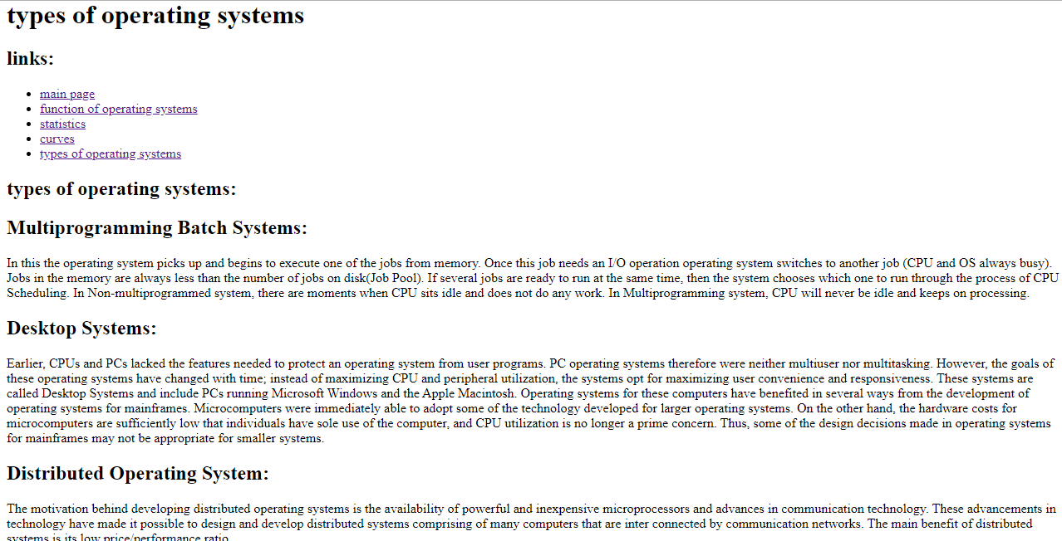

# **Application Brief:**

An OS (OS) is system software that manages hardware, software resources, and provides common services for computer programs.

Time-sharing operating systems schedule tasks for efficient use of the system and should also include accounting software for cost allocation of processor time, mass storage, printing, and other resources.

For hardware functions like input and output and memory allocation, the OS acts as an intermediary between programs and therefore the hardware,[1][2] although the appliance code is typically executed directly by the hardware and regularly makes system calls to an OS function or is interrupted by it. Operating systems are found on many devices that contain a computer – from cellular phones and computer game consoles to web servers and supercomputers.

The dominant desktop OS is Microsoft Windows with a market share of around 82.74%. macOS by Apple Inc. is in second place (13.23%), and therefore the sorts of Linux are collectively in third place (1.57%).[3] within the mobile sector (including smartphones and tablets), Android's share is up to 70% within the year 2017.[4] consistent with third quarter 2016 data, Android's share on smartphones is dominant with 87.5 percent with also a rate of growth of 10.3 percent per annum , followed by Apple's iOS with 12.1 percent with per annum decrease in market share of 5.2 percent, while other operating systems amount to only 0.3 percent.[5] Linux distributions are dominant within the server and supercomputing sectors. Other specialized classes of operating systems, like embedded and real-time systems, exist for several applications.

# 